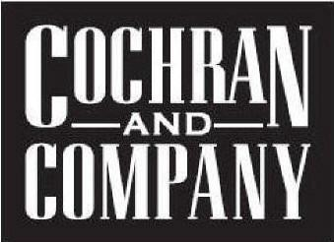

Devara (asi 49470) -World’s Finest Badge Holders and More! Phone #: 800-433-8272 – x 187; Website: www.devara.com ; Contact: Paula Baker - pbaker@devara.com – please send art to graphics@devara.com
Liqui-Mark (asi 67675) - Pens, Crayons, Highlighters, Dry Erase Markers, Permanent Markers; Phone #: 631-236-4333 Ext 214 ; Website: www.liquimark.com ; Contact: Debbie Ford d.ford@liquimark.com
FPS Apparel (asi 53475) - Custom Apparel Made Easy; Contact: Kristine Widulski kristine@fpsapparel.com ; Florida NY Phone #: 800-770-1720 ext. 120; Website www.fpsapparel.com
Burks Bay/Forsyth (asi #74600) –Leather Experts/Fitted Woven Shirts http://nucomltd.com/ Contact: Margie Gerard mgerard@burksbay.com Phone#: 800-352-7025 x 102 or Max Burkett mburkett@burksbay.com Phone#: 800-352-7025
Travel Chair-(asi#91916) High End Outdoor Travel Chairs and Equipment - www.travelchair.com Contact: Daniel Roso daniel@travelchair.com Phone : 253-851-7519
The Stadium Chair Company (asi 79912) - The Best Stadium Chair in America; Phone #: 800-777-3810; Website: www.stadiumchair.com ; Contact: Morgan Davis mdavis@all-starsports.com or customerservice@all-starsports.com
Big Wood Boards (asi#40501)-Made in USA- Personalized Walnut and Maple Cutting Boards and Serving Trays with or without handles in various shapes and sizes along with other Wood Accessories Contact: 404-355-0094 Gavron Campbell info@bigwoodboards.com, 0rders@bigwoodboards.com

Charlie Cochran charlie@cochranandcompany.net 706-888-3876

